BLADE SIGN GRANT GUIDELINES
Eligibility: Commercial and Mixed Use properties within the defined boundaries of the Lawrenceburg Main Street district are eligible for this program. The district extends from US50 south to the Levee bounded by Tanners Creek on the west and the Casino on the east and the area north of US50 to the Greendale boundary bounded by Tanners Creek on the west and Front Street on the east. Commercial property owners may apply for a grant once every 5 years. Previously completed projects are not eligible for funding.
Application Information: Applications will be accepted on a rolling basis and may be submitted by the property owner or the tenant. If submitted by the tenant, the application must include the approval and signature of the property owner. Submission of an application does not guarantee that a project will be funded. All applications will require the submission of 2 quotes for consideration. All quotes must be submitted on business letterhead. Applications will be reviewed by the Lawrenceburg Main Street Design Committee and passed on with a recommendation to the Main Street Board for final approval. The approval process may take up to 4 to 8 weeks.
Maximum Amount of Grant: Applicants may apply for grants up to $2500 providing all eligibility and match requirements are met and grant funding is available.
Owner Investment: For every $3 of grant funding, the grant recipient must provide a match of $1. Based on this formula, projects of up to $3333 would require approximately $833 investment from the owner in order to receive $2500 in grant funding. Labor performed by the owner or tenant on the project may not be counted as in kind matching funds.
Permitted Projects: The following sign projects are eligible:
New or refurbished blade signage

Appropriate Permits: Evidence of the proper permits must be included with the application. Applicants are required to contact Mike Clark, City Planning and Zoning, mdc@col-in.net, 812-532-3554, to review the project and obtain required permits. Failure to comply with permitting requirements will result in the withholding of grant funds.

Project Timelines: Approved projects must be completed within 6 months after grant approval. Projects completed in the past 6 months will also be considered. All invoices for funded projects submitted to the Main Street office by December 15th of the calendar year.
Distribution of Grant Funds: Grant funds will be distributed only after the recipient has expended their portion as per the signed grant agreement and the project has been completed. The recipient may be reimbursed for appropriate expenses only upon presentation of paid invoices and proof of payment (such as a cancelled check, valid receipt). Lawrenceburg Main Street reserves the right to inspect completed work before issuing payment.
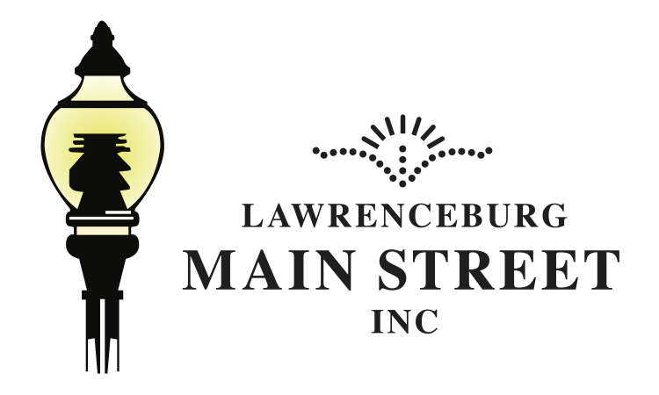BLADE SIGN GRANT APPLICATION
When applying for this grant please remember to read the attached Program Guidelines before
completing the application. Incomplete applications will not be considered.
*Download PDF to fill out application online or print
Applicants Name:_______________________________________________________
Address: ______________________________________________________________________
Telephone: ___________________________________Cell______________________________
Email: ________________________________________________________________________
If Applicant is other than Property Owner:
Property Owner’s Name:_______________________________________________________
Address: ______________________________________________________________________
Telephone: ___________________________________Cell______________________________
Total Estimated Cost of the Project: 1- ___________________ 2- ________________________
Address where sign is to be placed_________________________________________________
Do you currently have a blade sign? _____Yes _____No
Have you received a sign grant previously _____Yes _____No If so when____
For each quote, a rendering of the proposed sign including colors is attached _____Yes_____No
A photograph(s) of the property showing sign placement is attached _____Yes ____No
If the project requires a permit from the City of Lawrenceburg, a copy is attached ___Yes___No
If the project requires a Certificate of Appropriateness from the City of Lawrenceburg, a copy is
attached _________Yes _________No
I certify that I am able to provide the required matching funds for the project as outlined in this
application.
Applicant’s Signature ____________________________________Date ______________
If Applicable, Owner’s Signature____________________________Date_____________
City Zoning Dept. Signature_______________________________Date______________
CITY OF LAWRENCEBURG

PLAN COMMISSION
Lawrenceburg City Administration Building Office 812-532-3554
230 Walnut St, PO Box 4166 Fax 812-532-3559
Lawrenceburg, IN 47025 Email mdc@lawrenceburg.in.gov
Website thinklawrenceburg.com

Michael. D. Clark
Zoning Director

Zoning Attorney
Thomas Blondell

Blade Sign Grant Process

YES NO N/A
- Located in Levee Business District ____ ____ ____
- Pre-application Conference: Director of Engineering and Zoning ____ ____ ____
- Lawrenceburg City Business License ____ ____ ____
- Procure Final Design ____ ____ ____
- Historic Preservation Certificate of Appropriateness ____ ____ ____
- S&SE&O Permit
- Right-of-way Encroachment License ____ ____ ____
- Improvement Location Permit (SIGNAGE) ____ ____ ____
- Development Standards Variance ____ ____ ____
- Building Permit ____ ____ ____
- Professional Installation ____ ____ ____

Lawrenceburg Zoning Release ______________________________________________
Signature

